**Frequency Domain Filters and its Types**

**Frequency Domain Filters** are used for smoothing and sharpening of image by removal of high or low frequency components. Sometimes it is possible of removal of very high and very low frequency. Frequency domain filters are different from spatial domain filters as it basically focuses on the frequency of the images. It is basically done for two basic operation i.e., Smoothing and Sharpening.

These are of 3 types:

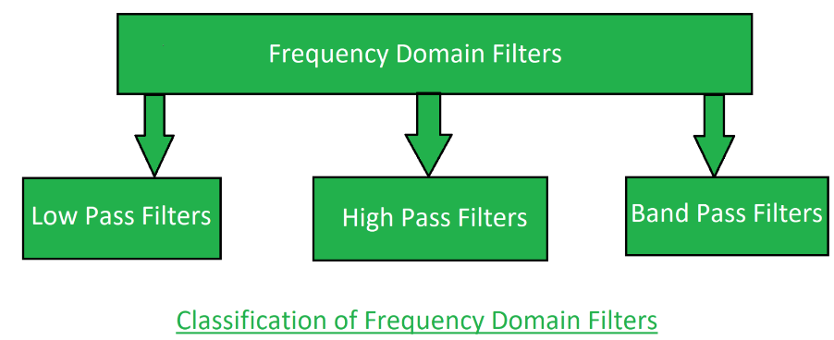

1. **Low pass filter:**  
   Low pass filter removes the high frequency components that means it keeps low frequency components. It is used for smoothing the image. It is used to smoothen the image by attenuating high frequency components and preserving low frequency components.  
   Mechanism of low pass filtering in frequency domain is given by:

G(u, v) = H(u, v) . F(u, v)

where F(u, v) is the Fourier Transform of original image

and H(u, v) is the Fourier Transform of filtering mask

1. **High pass filter:**  
   High pass filter removes the low frequency components that means it keeps high frequency components. It is used for sharpening the image. It is used to sharpen the image by attenuating low frequency components and preserving high frequency components.  
   Mechanism of high pass filtering in frequency domain is given by:

H(u, v) = 1 - H'(u, v)

where H(u, v) is the Fourier Transform of high pass filtering

and H'(u, v) is the Fourier Transform of low pass filtering

1. **Band pass filter:**  
   Band pass filter removes the very low frequency and very high frequency components that means it keeps the moderate range band of frequencies. Band pass filtering is used to enhance edges while reducing the noise at the same time.

**Smoothing lowpass filters**

**We can achieve smoothing in frequency domain through high-frequency attenuation (lowpass filtering). The 3 types of lowpass filters covers the range from very shap(ideal) to very smooth(Gaussian) filtering.**

**1. Ideal Lowpass Filters (ILPF)**

The lowpass filter which passes without attenuation of all frequencies within a radius **Do** from the origin and which cuts off all the frequencies outside this radius is called an ideal lowpass filter. The filter is specified by the following function:

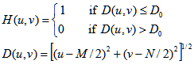

**where,**

**D0 = positive constant**

**D(u, v) = distance between a point (u,v) in the frequency domain and the center of the frequency rectangle.**

**M, N = padded sizes given as follows**

**M >= 2P -1**

**N >= 2Q — 1**

**P, N = array dimensions**

**Note: M and N are the padded sizes of the arrays.**

In the ideal pass filter all the frequencies on or inside the radius Do are passed without attenuation but all frequencies frequencies outside the circle are completely filtered. The filter is completely defined by a radial cross section as it is radially symmetric about the origin.

**2. Butterworth Lowpass Filters (BLPF)**

This filter is designed so as to have a flat frequency response in the passband. The frequency response is flat in the passband and rolls-off towards zro in the stopband. The rate of roll-off is based on the order of the filter.

The butterworth function is as:

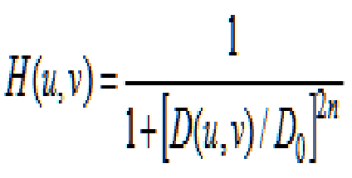

https://miro.medium.com/v2/resize:fit:514/1*3Z9pvrYJM_X_vPlNlS5ukA.png

where,

**Do = cutoff frequency distance**

**D(u, v) = distance between a point (u,v) in the frequency domain and the center of the frequency rectangle.**

**M, N = padded sizes given as follows**

**M >= 2P -1**

**N >= 2Q — 1**

**P, N = array dimensions**

Note: M and N are the padded sizes of the arrays.

BLPF transfer function does not have a sharp discontinuity that gives a clear cutoff between passed and the filtered frequencies. Butterworth filter with order 1 has no ringing in spatial domain which generally is imperceptible in filters of order 2 but can become significant in filters of higher order.

A Butterworth filter with order 20 has similar characteristics to Ideal pass filters.

A BLPF filter with order 2 is good compromise between effective lowpass filtering and acceptable ringing.

**3. Gaussian Lowpass Filters**

A Gaussian filter is a 2D convolution operator which is used to blur images and helps to eliminate noises in the image.

The main effect of this filter is to blur the image similarly to mean filters and the extend to smoothing is based on the standard deviation of the Gaussian.

GLPFs in two dimensions is given by:

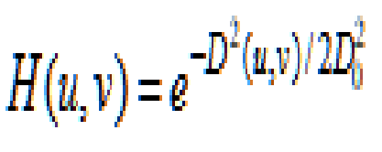

where,

**D(u, v) = distance between a point (u,v) in the frequency domain and the center of the frequency rectangle.**

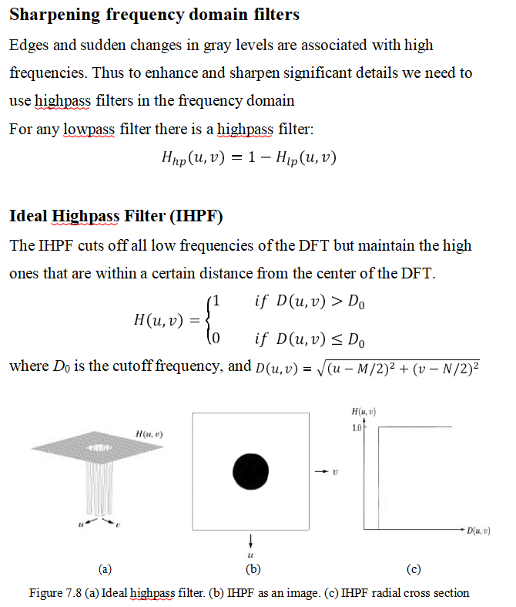

The IHPF sets to zero all frequencies inside a circle of radius *D*0 while passing, without attenuation, all frequencies outside the circle.

The figure below shows the results of applying IHPF with cutoff frequencies 15, 30, and 80.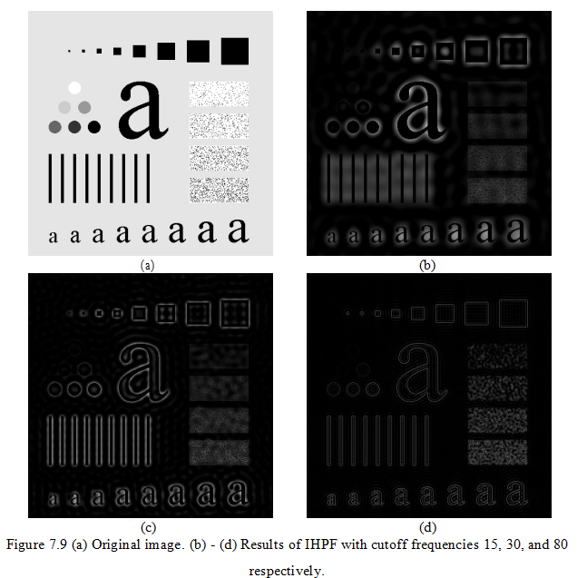

We can see the following effects of IHPF:

1. Ringing effect.

Edge distortion (i.e. distorted, thickened object boundaries). Both effects are decreased as the cutoff frequency increases.

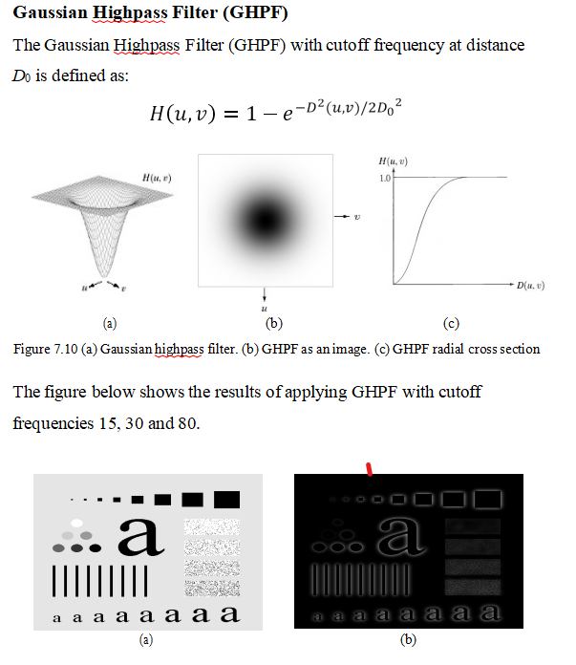

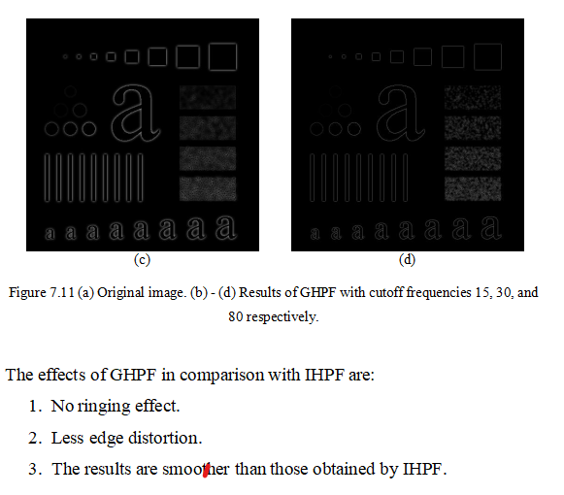

**Butterworth Highpass Filter (BHPF)** is used for image sharpening in the frequency domain. Image Sharpening is a technique to enhance the fine details and highlight the edges in a digital image. It removes low-frequency components from an image and preserves high-frequency components.

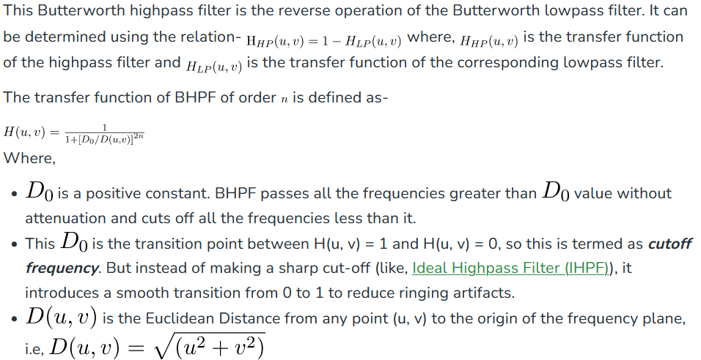

**Homomorphic Filter**

Homomorphic filtering is a generalized technique for signal and image processing, involving a nonlinear mapping to a different domain in which linear filter techniques are applied, followed by mapping back to the original domain. This concept was developed in the 1960s by Thomas Stockham, Alan V.

An image as a function can be expressed as the product of illumination and reflectance components as follows:

F(x,y) = I(x,y) * R(x,y)

It cannot be used directly to operate separately on the frequency components of illumination and reflectance because the Fourier transform of the product of two functions is not separable. Instead the function can be represented as a logarithmic function wherein the product of the Fourier transform can be represented as the sum of the illumination and reflectance components as shown below:

ln(x,y) = ln(I(x,y)) + ln(R(x,y)) (2) The Fourier transform of equation (2) is Z(u,v) = Fi(u,v) + Fr(u,v) (3) The fourier transformed signal is processed by means of a filter function H(u,v) and the resulting function is invers e fourier transformed. Finally, inverse exponential operation yields an enhanced image. This enhancement approach is termed as homomorphic filtering. The whole operation is expressed as a block diagram below:

F(x,y) G(x,y) ln DFT H(u,v) IDFT exp Implementa tion of Homomorphic

filtering Consider an image with 256 x 256 pixels where the pixels have varying intensity. The pattern goes from dark to light as we go from left to right. This is also called a horizontal intensity and it can be visualized by creating a matrix of size 256 with non-uniform illumination. This is the first illumination pattern under investigation.

